Aim: Simulate cross-correlation and autocorrelation on discrete-time signals.
Code:
import numpy as np
import matplotlib.pyplot as plt
def cross_correlation(signal1, signal2):
# Compute the cross-correlation
cross_corr = np.correlate(signal1, signal2, mode='full')
return cross_corr
def autocorrelation(signal):
# Compute the autocorrelation
auto_corr = np.correlate(signal, signal, mode='full')
return auto_corr
# Define the discrete-time signals
signal1 = np.array([1, 2, 3, 4, 5])
signal2 = np.array([2, 4, 6, 8, 10])
# Compute the cross-correlation
cross_corr = cross_correlation(signal1, signal2)
# Compute the autocorrelation
auto_corr = autocorrelation(signal1)
# Plot the cross-correlation and autocorrelation signals
plt.figure(figsize=(10, 6))
plt.subplot(2, 1, 1)
plt.stem(cross_corr)
plt.title('Cross-correlation')
plt.xlabel('Time Lag')
plt.ylabel('Magnitude')
plt.subplot(2, 1, 2)
plt.stem(auto_corr)
plt.title('Autocorrelation')
plt.xlabel('Time Lag')
plt.ylabel('Magnitude')
plt.tight_layout()
plt.show()
Output:
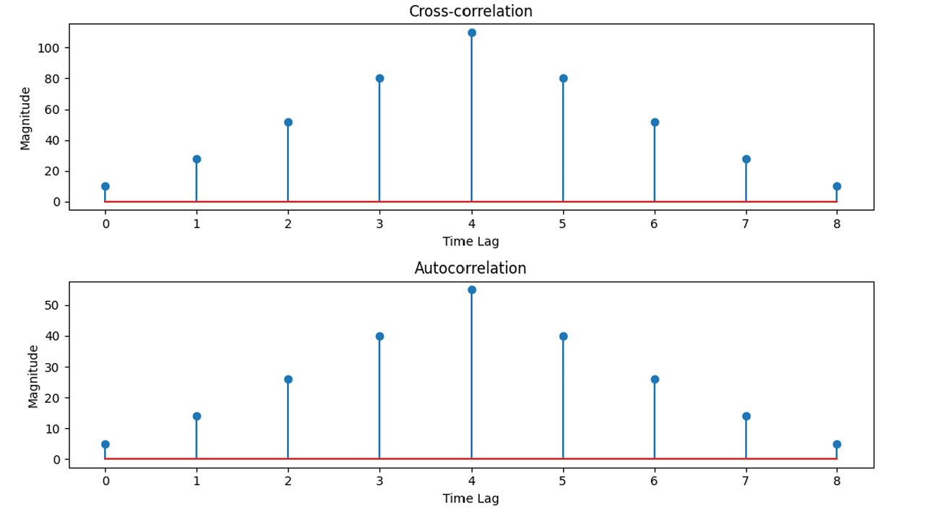

Conclusion: The simulation showed that autocorrelation measures the similarity of a signal with itself and has its maximum value at zero lag. Cross-correlation measures the similarity between two different signals and helps determine the time delay or alignment between them. Both are important techniques in digital signal processing for signal analysis and detection.

